CONTENT OPTIMIZATION
Tasks
1.Pick a recent trending topic from Instagram Reels or YouTube Shorts and write a 200-word blog post draft about it, making sure to include your chosen keyword at least 5 times.
=> Answer : Blog Post
Keyword : AI tools for students

AI Tools for Students: A New Study Trend in 2026

AI tools for students are becoming a trend on Instagram Reels and YouTube Shorts. Students use AI to understand difficult topics, create study plans, summarize notes, and practice questions. Instead of replacing learning, AI can make study time organized.

A major benefit of AI tools for students is personalized learning. A student can ask an AI tool to explain a difficult concept in simple language or provide examples. AI can also help students improve grammar, generate ideas for projects, and create revision notes.

However, AI tools for students should be used responsibly. Students should not copy answers blindly or submit AI-generated work as their own. They should check facts, understand the topic, and use AI as a learning assistant.

Another useful trend is AI-powered study planning. Students can enter their subjects, exam dates, and study hours to create a schedule. This can help reduce last-minute stress and improve consistency.

Overall, AI tools for students are changing how young people learn. When used wisely, they can save time, support understanding, and make studying engaging. The key is to use AI as a helper while keeping thinking and effort at the center.

2.Calculate the keyword density for the keyword 'discount' in the following Flipkart-style product description: 'Get the best discount on top mobiles. Discount offers available on Flipkart. Grab your discount now before it ends. Discount valid for today only.' Show your calculation and result as a percentage.<br><br><em><strong>Hint:</strong> Keyword density = (number of times keyword appears / total number of words) x 100.</em>
=> Answer :
- Total number of words = 24
- Keyword = discount
- Keyword appears = 4 times

Calculation:
Keyword Density = (4 ÷ 24) × 100
Keyword Density = 16.67%

3.Use the free Hemingway Editor (hemingwayapp.com) to check the readability score of your blog post draft from Task 1. Take a screenshot of the score and note down the Flesch Reading Ease value.

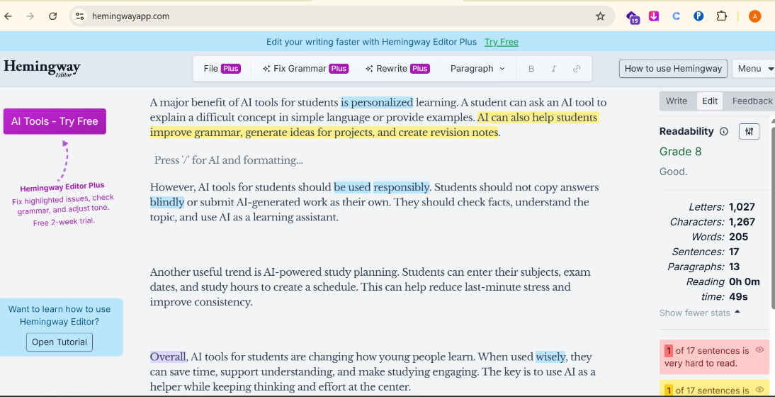

4.Decide the ideal content length for a blog post targeting the keyword 'best budget smartphones in India' by analyzing the top 3 Google search results. Write down the word count for each and suggest an optimal length for your own post.<br><br><em><strong>Hint:</strong> Use a browser extension or online tool to count words on each page.</em>

Search Result | Website | Approx. Word Count
1 | Beebom | 1,500 words
2 | MySmartPrice | 1,200 words
3 | Sportskeeda | 1,400 words
Average : (1500 + 1200 + 1400) / 3 = 1,367 words

5.Create a simple content refresh plan for a Zomato-style restaurant listing page. List 3 specific actions you would take to update the content and explain why each is important for SEO.
=> Answer :

1. Update Restaurant Information
Update the restaurant name, address, phone number, opening hours, menu, prices, and available services. This is important for SEO because accurate and fresh information improves user experience and helps search engines understand the business correctly.
2. Add Fresh Photos and Reviews
Add recent food photos and encourage customers to leave genuine reviews. Fresh visual content and user-generated reviews can improve engagement, build trust, and provide useful content related to the restaurant.
3. Improve SEO Content
Optimize the restaurant title, description, headings, and relevant local keywords such as “best restaurant in Ahmedabad” or “family restaurant in Ahmedabad.” This helps the listing appear for relevant local searches and can improve organic visibility.

